23CSE111

OBJECT ORIENTED PROGRAMMING LANGUAGE

LAB MANUAL



Amrita School of Engineering

Amrita Vishwa Vidyapeetham, Amaravathi

Name : V. KARTHIK SAI TEJ REDDY

Roll.No : AV.SC.U4CSE24343

WEEK – 1

Aim :- To Download and Install Java (JDK21)

Procedure :-

**Step 1: Download JDK**

Go to the official [Oracle website](https://www.oracle.com/java/technologies/downloads/#jdk22-windows) to download the JDK.

Choose **x64 MSI Installer** on the windows tab and click on download link.

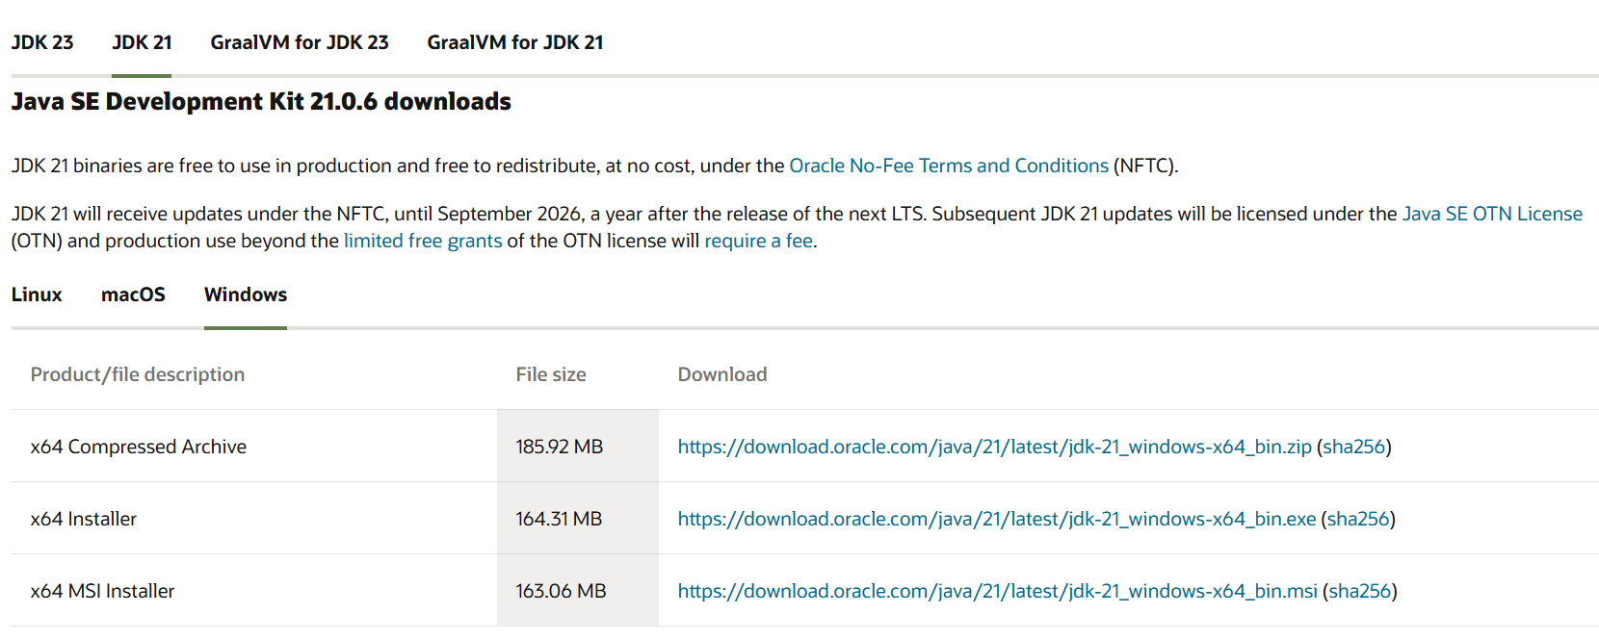

**Step 2: Run the Installer**

Now, go to your **downloads** folder and run the installer you just downloaded. You will be prompted to the screen below.

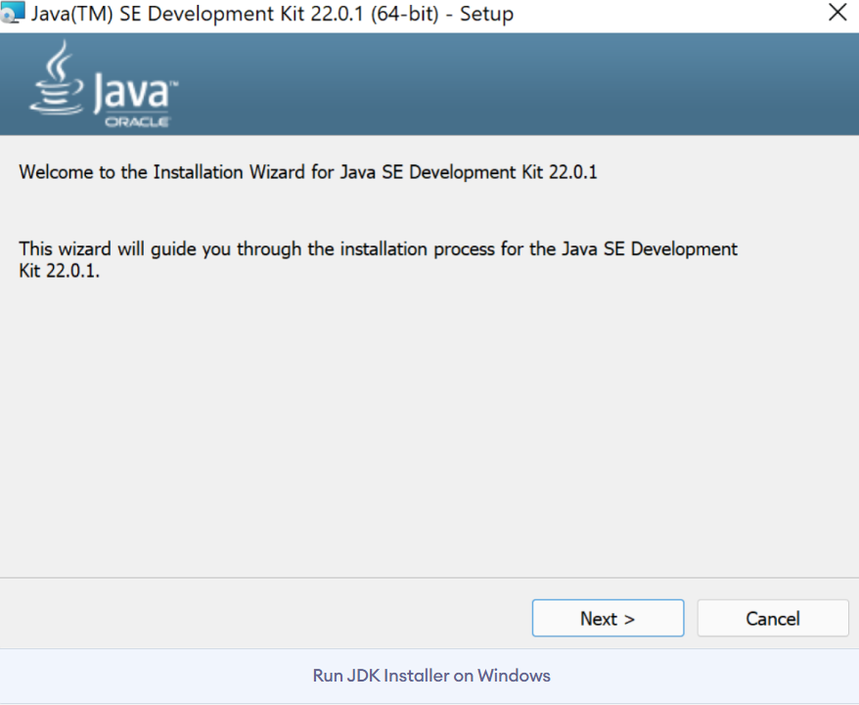

**Step 3: Configure Environment Variables**

After installation, you will need to tell your system where to find Java. This is done by setting environment variables.

**Update the Path Variable:**

Find the **Path** variable in the System variables section and click on **Edit**. Then, click **New** and paste your JDK bin path.

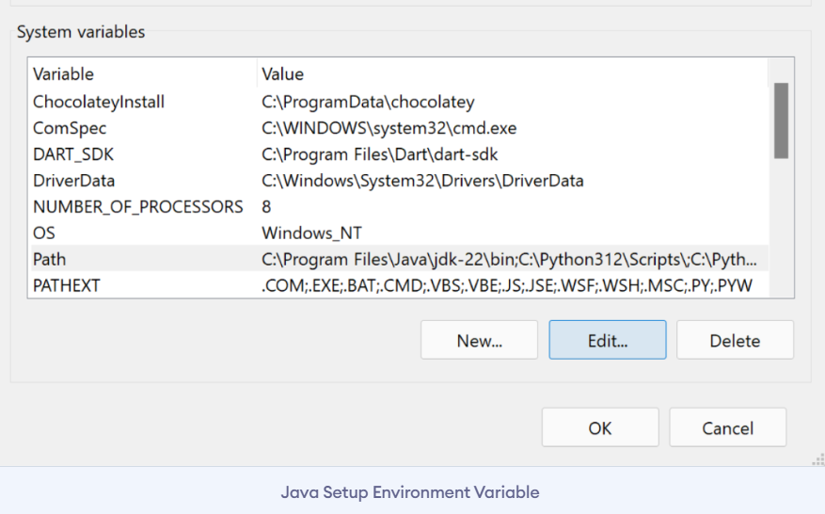

**Step 4: Verify your Installation**

After the installation, you can verify whether Java is installed by using the following command in the command prompt.

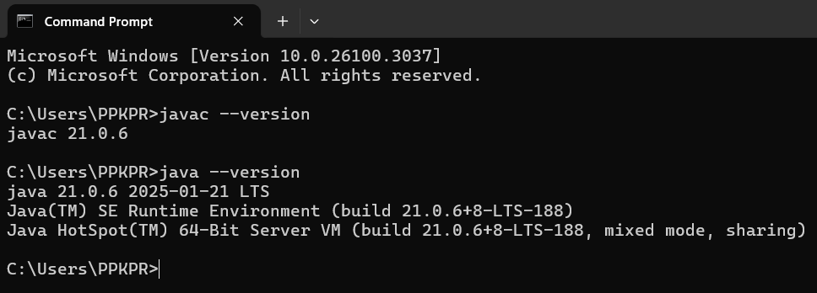

**Program – 1**

AIM :- // Write a JAVA Code to Execute First Java Program.

Code :-

class first

{

    public static void main (String ar[ ] )

    {

        //to print hello world

        System.out.println("HELLO WORLD....");

    }

}

|  |  |
| --- | --- |
| Code Error | Code rectification |
| 1. writing small “S”in place of”S”   In system.out.println()  2)not giving strings to the name and section | 1. code is rectified by keeping capital “S”   2)Giving strings to name and section |

OUTPUT:

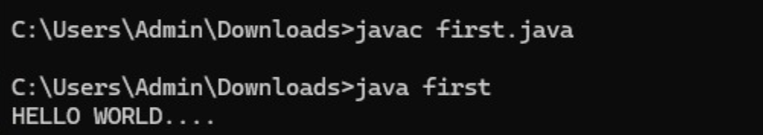

**Program – 2**

AIM :- // Write a JAVA Code to Print Student Details

Code :-

class student

{

    public static void main(String ar[])

    {

        System.out.println("Name    : KARTHIK ");

        System.out.println("Class   : CSE-C");

        System.out.println("Roll.No : AV.SC.U4CSE24343");

        System.out.println("Branch  : COMPUTER SCIENCE ENGINEERING");

        System.out.println("College : AMRITA VISHWA VIDHYAPEETHAM");

        System.out.println("AMARAVATHI");

    }

}

ERROR TABLE:

|  |  |
| --- | --- |
| **Code Error** | **Code rectification** |
| 1. writing small “S”in place of”S”   In system.out.println() | 1. code is rectified by keeping capital “S” |

OUTPUT :

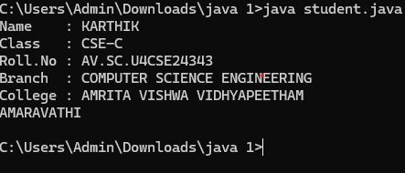

WEEK – 2

**Program – 1**

AIM :- // Write a JAVA Code to print Fibonacci Series.

Code :-

import java.util.Scanner;

class fibonacci

{

 public static void main(String ar[])

 {

    Scanner sc = new Scanner(System.in);

    System.out.println("Enter a value : ");

    int x=sc.nextInt();

    int a=0,b=1,c;

    System.out.println(a);

    System.out.println(b);

    for(int i=0;i<=x;i++)

    {

        System.out.println(a+"");

        c=a+b;

        a=b;

        b=c;

    }

 }

}

ERROR TABLE:

|  |  |
| --- | --- |
| **Code Error** | **Code rectification** |
| 1. Giving space between next and Double. 2. Not giving parenthesis after closing the input. | 1. Should not give space between next and Double. 2. We must put parenthesis after closing the input. |

OUTPUT:

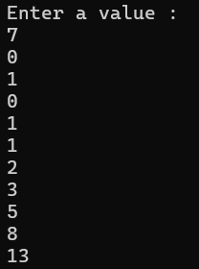

Program – 2

AIM :- // Write a JAVA Code to find Factorial of a given number

Code :-

import java.util.Scanner;

class factorial

{

    public static void main(String ar[])

    {

        Scanner sc = new Scanner(System.in);

        System.out.println("Enter a number : ");

        int n = sc.nextInt();

        int x=1;

        for(int i=1;i<=n;i++)

        {

            x=x*i;

        }

        System.out.println("Factorial of Number : "+x);

    }

}

ERROR TABLE:

|  |  |
| --- | --- |
| **Code Error** | **Code rectification** |
| 1. While using for iteration, not giving the conditions correctly. 2. Declaring the data type as double instead of int. | 1. We should give iterative statements correctly. 2. We should give the data type as int for integers. |

OUTPUT:

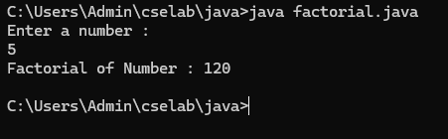

Program – 3

AIM :- // Write a JAVA Code to calculate Simple Interest.

Code :-

import java.util.Scanner;

class SI

{

    public static void main(String ar[])

    {

        float si;

        Scanner input=new Scanner(System.in);

        System.out.println("Enter Principle amount : ");

        int p=input.nextInt();

        System.out.println("Enter Rate of Interest : ");

        float r=input.nextFloat();

        System.out.println("Enter Time in Years : ");

        int t=input.nextInt();

        si=(p*t*r)/100;

        System.out.println("Simple Interest : "+si);

    }

}

ERROR TABLE:

|  |  |
| --- | --- |
| **Code Error** | **Code rectification** |
| 1. Giving space between next and Double. 2. Not giving parenthesis after closing the input. | 1. Should not give space between next and Double. 2. We must put parenthesis after closing the input. |

OUTPUT:

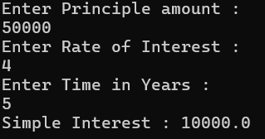

**Program – 4**

AIM :- // Write a JAVA Code to convert Celsius temperature into Fahrenheit temperature and vice versa.

Code :-

import java.util.Scanner;

class temp

{

public static void main (String ar[])

{

Scanner sc = new Scanner(System.in);

System.out.println("Enter 0 to convert Celcius into Fahrenheit Temperature.");

System.out.println("Enter 1 to convert Fahrenheit into Celcius Temperature.");

int n = sc.nextInt();

if (n==0)

{

System.out.println("Enter Temperature : ");

float x = sc.nextFloat();

double t=(x*1.8)+32;

System.out.println("Converted Temperature : "+t);

}

else if (n==1)

{

System.out.println("Enter Temperature : ");

float x = sc.nextFloat();

double t=(x-32)/1.8;

System.out.println("Converted Temperature : "+t);

}

else

{

System.out.println("Enter Valid Input");

}

}

}

ERROR TABLE:

|  |  |
| --- | --- |
| **Code Error** | **Code rectification** |
| 1. While printing the variable not giving + sign. 2. Not closing the scanner. | 1. We should give correct indentation. 2. Closing the scanner is must. |

Output

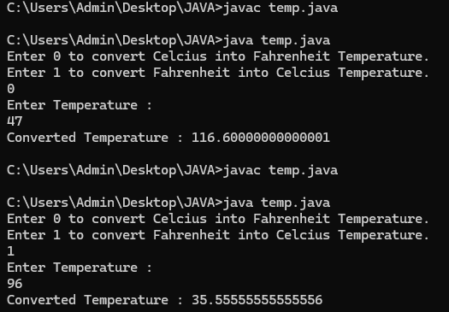

Program – 5

AIM :- // Write a JAVA Code to calculate Area of Rectangle and Area of Triangle using herons formula.

Code :-

import java.util.Scanner;

class area

{

public static void main(String ar[])

{

Scanner sc = new Scanner(System.in);

System.out.println("Enter Length of Rectangle : ");

float x = sc.nextFloat();

System.out.println("Enter Breadth of Rectangle : ");

float y = sc.nextFloat();

float z=x*y;

System.out.println("Area of Rectangle : "+z);

System.out.println(“To find Area of Triangle”);

System.out.println("a : ");

double a=sc.nextDouble

System.out.println("b : ");

double b=sc.nextDouble();

System.out.println("c : ");

double c=sc.nextDouble();

double s = a+b+c/2;

double area = Math.sqrt(s*(s-a)*(s-b)*(s-c));

System.out.println("Area of Triangle : "+s);

input.close();

}

}

ERROR TABLE:

|  |  |
| --- | --- |
| **Code Error** | **Code rectification** |
| Not closing scanner with semicolon | Closing the scanner is must |

OUTPUT:

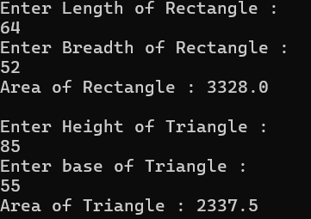

WEEK – 3

Program - 1

AIM :- Write a JAVA Code to create java program with following instructions

1.Create a class with name car

2. Create four attributes named car_color ,Car_brand,fuel_type,mileage

3. Create three methods named start(), stop(). Service()

4. Create three objects named car1,car2 and car3

Code:-

import java.util.*;

class car

{

    public String Car_color;

    public String Car_brand;

    public String fuel_type;

    public int mileage;

   public void start()

   {

       System.out.println("Car Started:");

       System.out.println("Car color is :"+Car_color);

       System.out.println("Car Brand is:"+Car_brand);

       System.out.println("Car fuel type is:"+fuel_type);

       System.out.println("Car mileage is:"+mileage);

   }

    public void service()

   {

       System.out.println("Car Started:");

       System.out.println("Car color is :"+Car_color);

       System.out.println("Car Brand is:"+Car_brand);

       System.out.println("Car fuel type is:"+fuel_type);

       System.out.println("Car mileage is:"+mileage);

   }

    public void stop()

   {

       System.out.println("Car Started:");

       System.out.println("Car color is :"+Car_color);

       System.out.println("Car Brand is:"+Car_brand);

       System.out.println("Car fuel type is:"+fuel_type);

       System.out.println("Car mileage is:"+mileage);

   }

public static void main(String args[])

{

    car car1 = new car();

    car1.Car_color = "Pink";

    car1.Car_brand = "Audi";

    car1.fuel_type = "Deisel";

    car1.mileage = 100;

   car1.start();

    car car2 = new car();

    car2.Car_color = "Black";

    car2.Car_brand = "Tesla";

    car2.fuel_type = "EV";

    car2.mileage = 200;

    car2.stop();

    car car3 = new car();

    car3.Car_color = "Blue";

    car3.Car_brand = "BMW";

    car3.fuel_type = "Petrol";

    car3.mileage = 300;

    car1car3.service();

 }

}

ERROR TABLE:

|  |  |
| --- | --- |
| **Code Error** | **Code rectification** |
| car.java:44: error: ';' expected  car1.start() | By giving semicolon at last to statement. |

**Class diagram:**

|  |
| --- |
| **car**  **-----------------------**  **-car_color:string**  **-car_brand:string**  **-fuel_type:string**  **-milage:double**  **----------------------**  **+start():void**  **+stop():void**  **+service():void** |

OUTPUT :

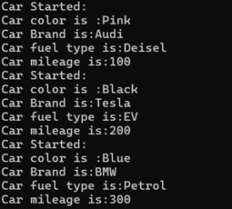

**Program – 2**

AIM :-// Write a JAVA Code to create a class bankAccount with methods deposit() and withdrawl

Code :-

public class BankAccount {

    public double balance;

    public BankAccount(double initialBalance) {

        balance = initialBalance;

    }

    public void deposit(double amount) {

        if (amount > 0) {

            balance += amount;

            System.out.println("Deposited " + amount + ". New balance is " + balance);

        } else {

            System.out.println("Deposit amount must be positive.");

        }

    }

    public void withdraw(double amount) {

        if (amount > 0 && amount <= balance) {

            balance -= amount;

            System.out.println("Withdrew " + amount + ". New balance is " + balance);

        } else {

            System.out.println("Invalid withdrawal amount. Check your balance.");

        }

    }

    public static void main(String[] args) {

        BankAccount account = new BankAccount(100); // Initial balance of 100

        account.deposit(100000);

        account.withdraw(30000);

        account.withdraw(1500); // Invalid withdrawal

    }

}

ERROR TABLE :

|  |  |
| --- | --- |
| **Code Error** | **Code rectification** |
| Parenthesis is missing | Added parenthesis to the statement. |

Class diagram:

|  |
| --- |
| BankAccount  ----------------------------------------------------------  -balance: double  ----------------------------------------------------------  +BankAccount(intialBalance: double)  +deposit(amount: double):void  +withdraw(amount: double):void |

OUTPUT :



WEEK – 4

Program - 1

Aim :- Write a java program with class named book. A class should contain various attributes such as title, author, year of publication. It should also contain a constructor with parameters which initializes title, author and year of publication. Create a method which displays the details of the book. Display the details of two books.

Code :-

public class book

{

    String title;

    String author;

    int year;

    // Constructor

    public book(String title, String author, int year) {

        this.title = title;

        this.author = author;

        this.year = year;

    }

    // Method

    public void displayDetails() {

        System.out.println("Title: " + title);

        System.out.println("Author: " + author);

        System.out.println("Year of publication: " + year);

        System.out.println();

    }

    public static void main(String[] args) {

        //objects

        book book1 = new book("book 1", "author 1", 1999);

        book book2 = new book("book 2", "author 2", 2000);

        //book details

        System.out.println("Book 1 Details:");

        book1.displayDetails();

        System.out.println("Book 2 Details:");

        book2.displayDetails();

    }

}

ERROR TABLE:

|  |  |
| --- | --- |
| **Code Error** | **Code rectification** |
| book.java:28: error: cannot find symbol  book1.display(); | By adding,  book1.displayDetails(); |

Class diagram:

|  |
| --- |
| book |
| - title: String  - author: String  - year: int |
| + Book(title: String, author: String, year: int)  + displayDetails(): void |
| + main(args: String[]): void |

Output:

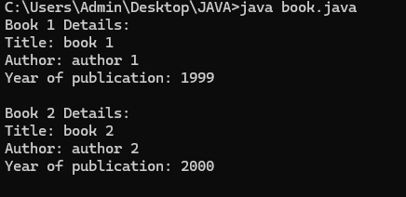

Program – 2

Aim :- Create a java program with class name “myclass” with static variable count of int type. Initialize it to zero and a constant variable pi of type double. Initialize pi to 3.14 as attributes of class. Now define a constructor for “myclass” that increments the count variable each time an object of “myclass” is created. Finally print the final values of count and pi variables. Create three objects.

Code :-

public class myclass

{

    static int count = 0;

    final double PI = 3.14;

    myclass() {

        count++;

    }

    void display() {

        System.out.println("Count: " + count);

        System.out.println("PI: " + PI);

    }

    public static void main(String[] args) {

        myclass obj1 = new myclass();

        myclass obj2 = new myclass();

        myclass obj3 = new myclass();

        obj3.display();

    }

}

ERROR TABLE:

|  |  |
| --- | --- |
| **Code Error** | **Code rectification** |
| myclass.java:7: error: illegal start of expression  count+; | By adding,  count++; |

Class diagram:

|  |
| --- |
| myclass |
| - static count: int  - final PI: double |
| + MyClass()  + display(): void  + main(args: String[]): void |

Output:

